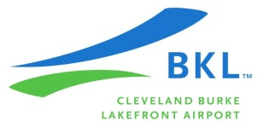
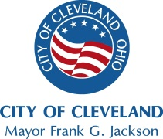
Notice of Availability

FINAL ENVIRONMENTAL ASSESSMENT (EA)
FINDING OF NO SIGNIFICANT IMPACT (FONSI)
For Proposed Improvements to the Runway 6L-24R Safety Area (RSA) at Burke Lakefront Airport (BKL)

The Federal Aviation Administration (FAA) has approved a Finding Of No Significant Impact (FONSI) for the proposed safety area improvements to Runway 6L-24R at Burke Lakefront Airport, Cleveland, Ohio. The FONSI is being made available to the public pursuant to Part 1506 of the Council on Environmental Quality Regulations concerning implementation of the National Environmental Policy Act. Copies of the Final EA and FONSI are located at:

Cleveland Hopkins International Airport
Planning & Engineering
Meenakshi Singh
Planning Manager
19501 Five Points Road
Cleveland, Ohio 44135

For questions or further information, please contact Meenakshi Singh, Planning Manager, Cleveland Airport System at 216-265-2722 or msingh@clevelandairport.com.

